Ivonne Santoyo-Orozco
Architectural Association School of Architecture

Mario Pani Darqui (1911 − 1993)

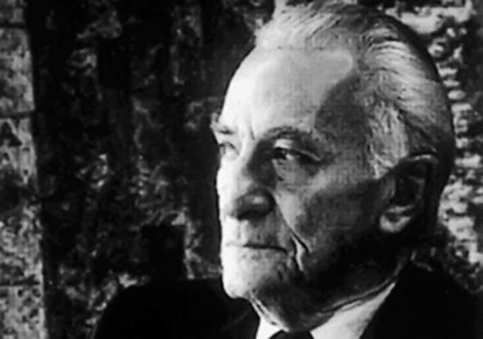
Mario Pani Darqui
http://noticias.arq.com.mx/Detalles/14857.html#.Uj9jsBZpDx5

The Mexican architect, Mario Pani, spent his formative years between Belgium, Italy and France due to his father’s diplomatic posts. After graduating from the Écoles des Beaux-Arts (1934), he returned to Mexico just before a period of massive urban transformation in Mexico City. During his first decades in Mexico, Pani worked intensively to establish his career. In very little time, he began to win his first commissions. Of those early years the most important was perhaps Hotel Reforma (1936), which Pani controversially took over from Carlos Obregón Santalicia. Apart from this, his early career in Mexico saw him actively participating in many competitions against the most renowned architects of his time. In 1938 he founded the magazine Arquitectura/México (1938-1979) not only to disseminate contemporary architecture in Mexico, but also, to republish material from international magazines.

Over the course of his career, Pani designed a huge variety of projects ranging from educational buildings, such as the National Conservatory of Music (1946), the National School of Teachers (1947) or his famous Rectory Building in Mexico City (1952); touristic complexes such as the Acapulco Yacht Club (1955); administrative centres like Condominio Acero in Monterrey (1959) and urban plans such as the Medical Center Masterplan (with Jose Villagran Garcia, 1942), the University Campus of the National Autonomous University (with Enrique del Moral, 1952), among many others. Yet, Mario Pani is more commonly remembered for his housing projects.

Following the Mexican Revolution, Mexico city began experiencing a population explosion and many were living in precarious conditions. A general housing shortage had become a broad concern for the city, and Pani was determined to take action in such a problem at an urban scale. He impatiently commented, “we must build for all… Plan! Build! Plan well! Build now!” With this enthusiasm, and influenced by Le Corbusier’s Ville Contemporaine (1922) and Ville Radieuse (1924), Pani began promoting for the first time in Mexico City high density housing projects in response to Mexico City’s urgent social needs. During his life Pani designed over 300,000 apartments in Mexico. His first large scale project was the Multifamiliar Presidente Miguel Aleman, a housing development of approximately 1000 housing units. It was the first large scale project in Mexico following modernist principles. Yet, perhaps his largest and most memorable built endeavour was the Habitational City of Nonoalco-Tlateloco (1966). This development was designed as a vertical city on 198 acres located just outside the city centre. It was to house about 70000 inhabitants and was organised in 101 buildings together with the iconic, triangular profile administration building topped by a belfry. This project is controversial to this date for lacking social cohesion and Pani’s conscious avoidance of the cultural and historical importance of the site.

While a great majority of his work is still in use, much of it has been heavily damaged or destroyed by historical events. His project in Tlatelololco was the site of a student massacre in 1968 and heavily damaged by the 1985 earthquake in Mexico City. Other projects such as, Centro Urbano Presidente Juarez (1952), a housing development of 25000 sqm, was also partially demolished following the earthquake. In spite of this, his work is widely appreciated. Among many awards, he was a recipient of the National Prize for Arts of 1986.

Selected Works:
1936. Hotel Reforma, Mexico City.
1942. Medical Center Masterplan, Mexico City (with Jose Villagran Garcia.
1947. National School of Teachers, Mexico City.
1946. National Conservatory of Music, Mexico City.
1950. Multifamiliar Presidente Miguel Aleman, Mexico City.
1951. Regional plan for Yucatán, Yucatán.
1952. Centro Urbano Presidente Juarez, Mexico City..
1952. Masterplan for the University Campus of the National Autonomous University, Mexico City (with Enrique del Moral).
1952. Rectorate Tower, Mexico City.
1952. Regional plan for Acapulco, Acapulco, Guerrero, Mexico..
1956. Apartment Building in Reforma and Guadalquivir, Mexico City (With Salvador Ortega)
1966. Ciudad Habitacional Nonoalco-Tlatelolco, Mexico City. (with Luis Ramos Cunningham and Ricardo de Robina).

References and further reading:
Garay, Graciela. (2000) Mario Pani, Historia Oral de la Ciudad de México, Mexico City: Conaculta and Instituto Mora.
Adriá Miquel. (2005) Mario Pani: La Construcción de la Modernidad, Mexico City: Gustavo Gili and Conaculta.
Larrosa, Manuel. (1985) Mario Pani, Arquitecto de su Época, Mexico City: Universidad Nacional Autónoma de Mexico.

Visual Material:
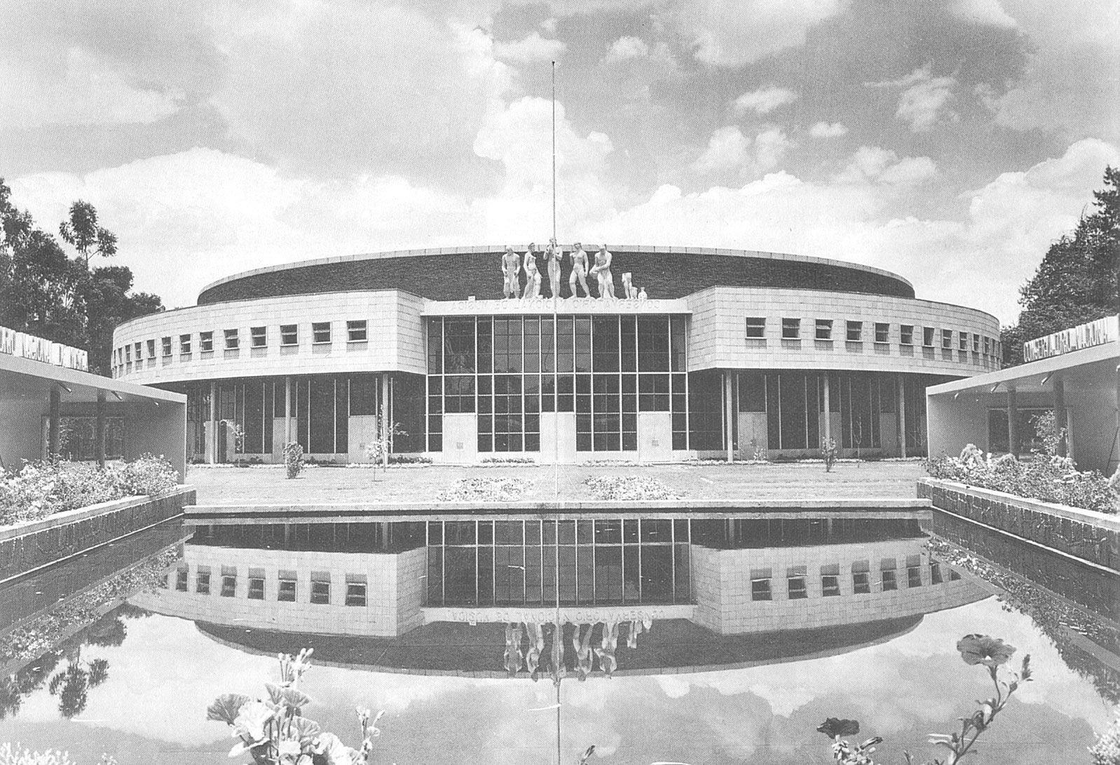
National Conservatory of Music, Mexico City.
1946
http://polancoayeryhoy.blogspot.co.uk/2011/03/el-edificio-del-conservatorio.html

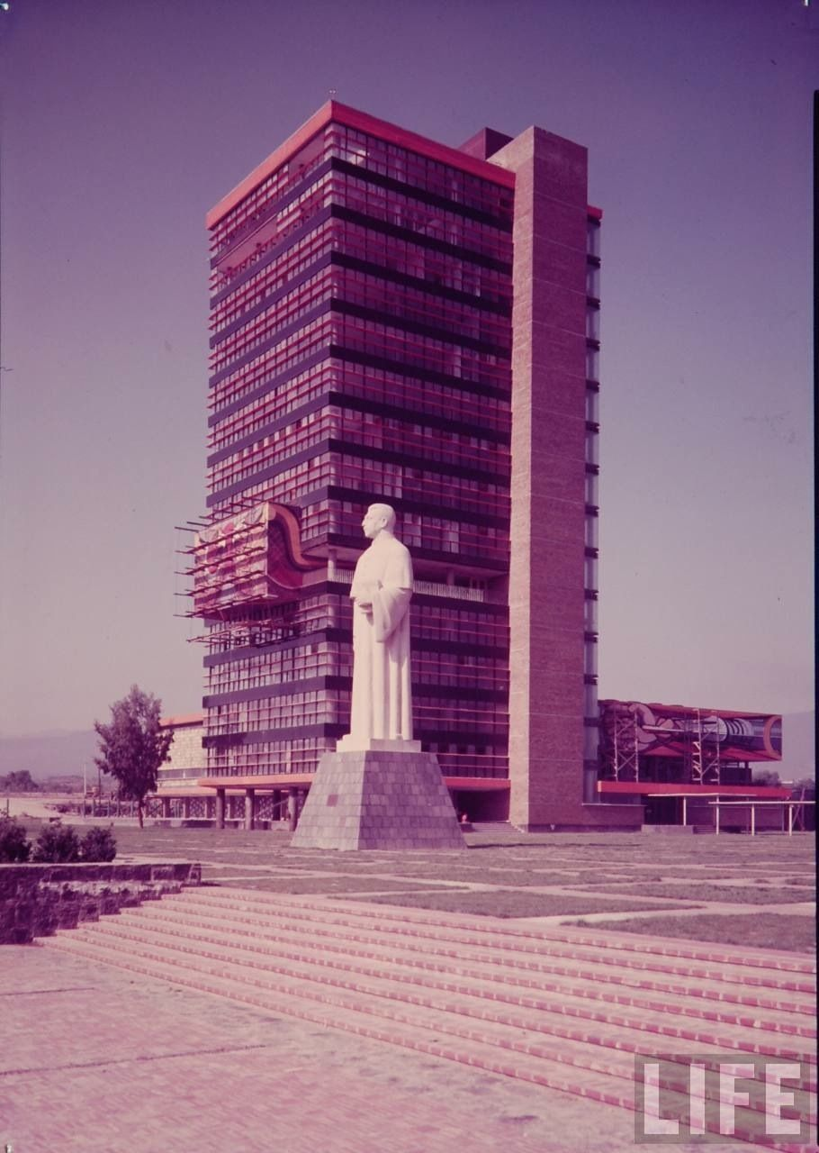
Rectorate Tower, Mexico City.
1952
Copyright: Eliot Elisofon via LIFE
http://architectureofdoom.tumblr.com/image/57404067536

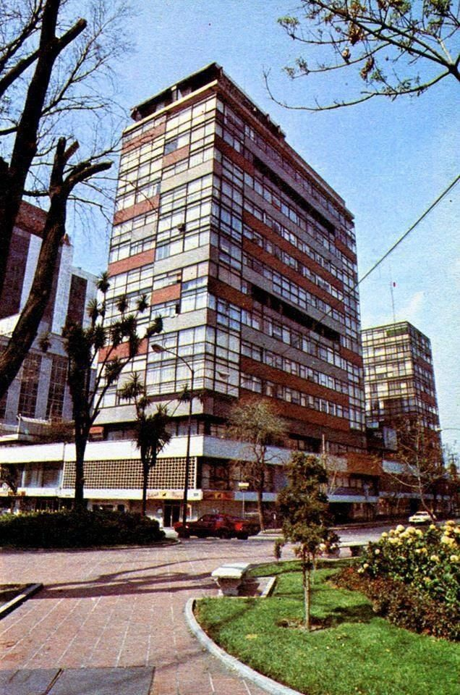
Apartment Building in Reforma and Guadalquivir, Mexico City (With Salvador Ortega).
1956
https://twitter.com/cdmexeneltiempo/status/358477055110819840

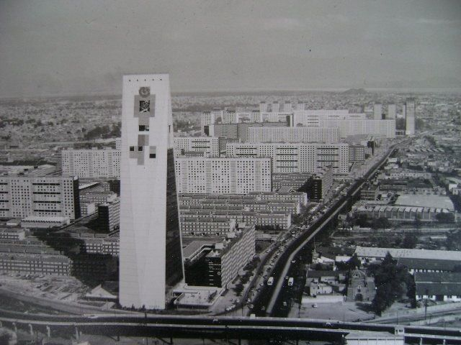
Ciudad Habitacional Nonoalco-Tlatelolco, Mexico City.
1966.
http://memoriaurbana.foroactivo.com/t153-tlaltelolc

Smith, Olive B. (1967) Builders in the Sun: Five Mexican Architects, Texas, USA: Architectural Book Publishing Comany, page 176.

